**NoSQL – MongoDB- Document Database -2**

AggregatedQueries- usefulforbasicextractionofdata,butanypost-processingwould be up to the user to handle.

->Count the phone numbers greater than 559–9999;

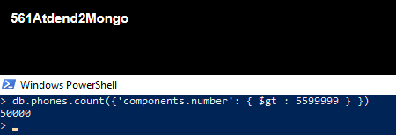

Contd.Innextpage

Additionofaddanother100,000phonenumberstoour phonescollectionbymodificationof populatePhones() function to give you a random country code between 1 and 8:

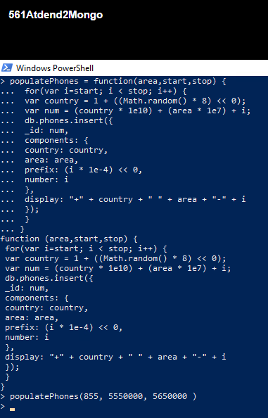

* 1. Distinct()

Fetchedthedistinctcomponentnumbersthatarelessthan 5,550,005:

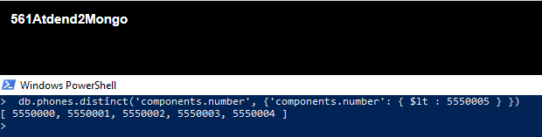

* 1. Group()

Countallphonenumbersgreaterthan5,599,999andgroupthe resultsintodifferentbucketskeyedby area code:

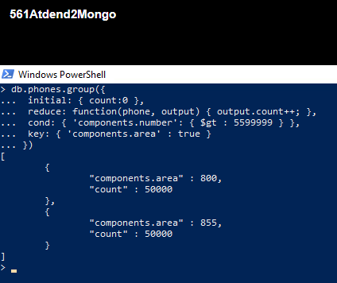

* + - A2.2Section4-MapReduce(andFinalize)

Generate are port that counts all phone numbers that contain the same digits for each country usinga helper function that extracts an array of all distinct numbers and saving it.

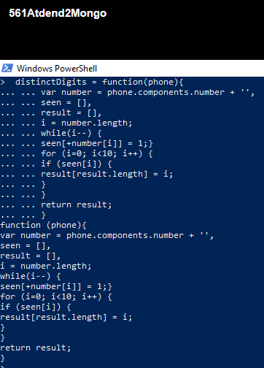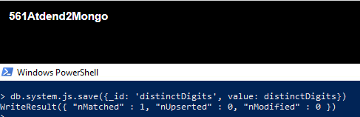

Invokedthefunction:

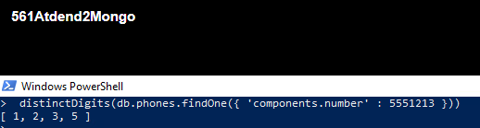

Mapperfunction -emitsthevalue1

Reducer’sjob-sumallthose1stogether Assemble theparts :

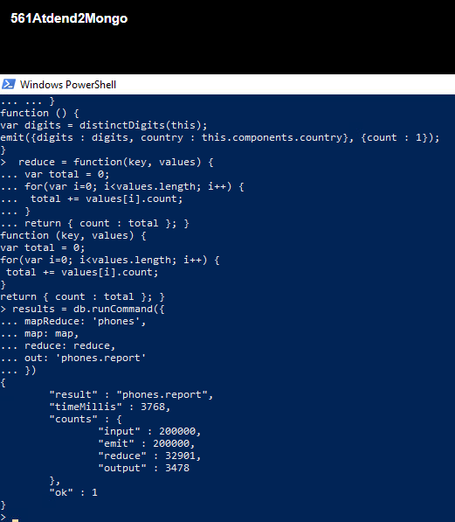

Query: thedistinct digitcountforallphoneentriesthat haveacountrycode=8

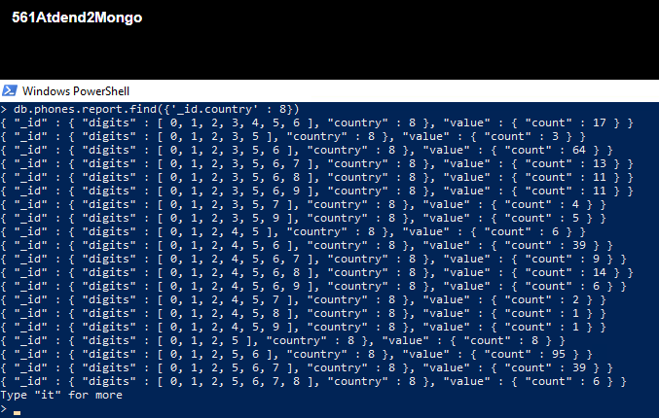

Implement a finalize method that outputs the count as a total. To do this, you need to create and add a finalize function that renames the attribute count to total. Then add the finalize attribute to your MapReduce command. You should include your results using db.phones.report.find() Ex: { "_id" : { "digits":[ 0,1,2,3,4,5,6],"country" :8},"value":{"count":13}}to{"_id":{"digits":[0,1,2,3,4, 5, 6 ], "country" : 8 }, "value" : { "total" : 13 } }

Steps of implementation:

1. Finalize function is implemented.
2. Added finalize function in mapreduce and executed it using runCommand
3. The above modification is found out using findEx: db.phones.report.find()
4. The result is as follows:

Contd.innextpage

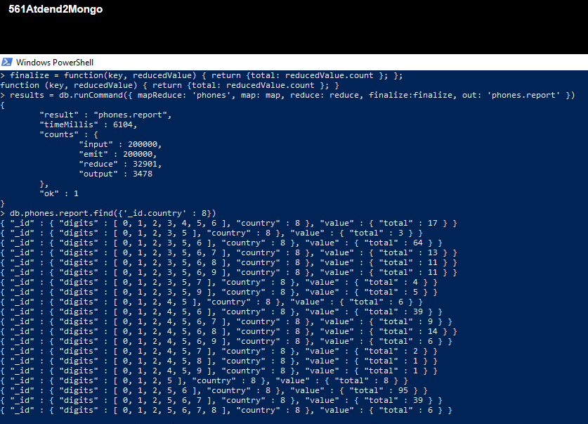

=======================================THEEND=============================